- SYSTEM DESIGN

This presents the logical data model that defines entities required for Intelligence Bureau application tables.

Overview

The entities in the logical data model have been logically grouped for ease of understanding. Explanation is not needed for each entity and its attribute of that entity.

Standards and Techniques

In order to create the diagrams the Oracle and the Designer 2000 standards established by TCS have been followed. Some additional standards and techniques explained below have also been used to ensure consistency in the design.

Conventions

The entities and attributes have been named as per the SGV standard conventions.

DATABASE DESIGN
Table 3.5.1 Person Table
Field | Type | Null | Key
DB_ID | BIGINT(20) | NO | FK(database_mst)
LOC_ID | BIGINT(20) | NO | FK( LocationDb )
LANG_ID | BIGINT(20) | NO | FK(lang_mst)
PERSON_ID | BIGINT(20) | NO | PK
PERSON_CODE | BIGINT(20) | NO
FIRST_NAME | VARCHAR(50) | NO
MIDDLE_NAME | VARCHAR(50) | YES
LAST_NAME | VARCHAR(50) | YES
DOB | DATETIME | YES
AGE | BIGINT(20) | NO
GENDER_LOOKUPID | BIGINT(20) | NO | FK(lookup_mst)
RELIGION_LOOKUPID | BIGINT(20) | YES | FK(lookup_mst)
RELIGION_OTHER | VARCHAR(50) | YES
NATIONALITY_ID | BIGINT(20) | YES | FK
PERSON_CASTE | VARCHAR(50) | YES
CATEGORY | VARCHAR(20) | YES
OCCUPATION_LOOKUPID | BIGINT(20) | YES | FK(lookup_mst)
OCCUPATION_OTHER | VARCHAR(50) | YES
COUNTRY_ID | BIGINT(20) | NO | FK( NationalityDb)
IS_ADULT | CHAR(1) | YES
MARITAL_LOOKUPID | BIGINT(20) | YES | FK(lookup_mst)
MARRIAGE_DURATION | DECIMAL (10,0) | YES
RES_WITH_INLAWS | BIGINT(20) | YES
IS_INJURED | BIGINT(20) | YES
DATE_IDENTIFIED | DATETIME | YES

Table 3.5.2 City Table
Field | Type | Null | Key
CITY_ID | BIGINT(20) | NO | PRI
DISTRICT_ID | BIGINT(20) | YES | FK(DistrictDb)
LANG_ID | BIGINT(20) | NO | FK(lang_mst)
CITY_NAME | VARCHAR(50) | NO
CITY_CODE | VARCHAR(10) | NO

Table 3.5.3 Contact Table
Field | Type | Null | Key
SR_NO | BIGINT(20) | NO | PK
PERSON_ID | BIGINT(20) | YES | FK(PersonDb)
MASTER_LOOKUPID | BIGINT(20) | NO | FK(lookup_mst)
RESIDENCE_PHONE | BIGINT(20) | YES
OFFICE_PHONE | BIGINT(20) | YES
MOBILE | BIGINT(20) | YES
EMAIL | VARCHAR(150) | YES
FAX | BIGINT(20) | YES

Table 3.5.4 Country Table
Field | Type | Null | Key
COUNTRY_ID | BIGINT(20) | NO | PK
COUNTRY_NAME | VARCHAR(50) | NO
COUNTRY_CODE | VARCHAR(10) | NO
LANG_ID | BIGINT(20) | NO | FK(lang_mst)

Table 3.5.5 District Table
Field | Type | Null | Key
DISTRICT_ID | BIGINT(20) | NO | PRI
STATE_ID | BIGINT(20) | NO | FK(StateDb)
LANG_ID | BIGINT(20) | NO | FK(lang_mst)
DISTRICT_NAME | VARCHAR(50) | NO
DISTRICT_CODE | VARCHAR(10) | NO
POPULATION | BIGINT(20) | YES

Table 3.5.6 Language Table
Field | Type | Null | Key
LANG_ID | BIGINT(20) | NO | PK
LANG_NAME | VARCHAR(20) | NO
LANG_SHORT_NAME | VARCHAR(10) | NO

Table 3.5.7 Location Table
Field | Type | Null | Key
LOC_ID | BIGINT(20) | NO | PK
LOC_NAME | VARCHAR (100) | NO
LOC_SHORT_NAME | VARCHAR(30) | NO
LANG_ID | BIGINT(20) | NO | FK(lang_mst)
DEPARTMENT_ID | BIGINT(20) | NO | FK(lookup_mst)
PARENT_LOC_ID | BIGINT(20) | NO
LOC_ADDR_1 | VARCHAR(50) | YES
LOC_ADDR_2 | VARCHAR(50) | YES
LOC_CITY_ID | BIGINT(20) | YES | FK(CityDb)
LOC_DISTRICT_ID | BIGINT(20) | YES | FK(DistrictDb)
LOC_STATE_ID | BIGINT(20) | YES | FK(StateDb)
LOC_PIN | VARCHAR(10) | NO
TYPE_LOOKUP_ID | BIGINT(20) | NO | FK(lookup_mst)
START_DATE | DATETIME | NO
END_DATE | DATETIME | YES
ACTIVATE_FLAG | BIGINT(10) | NO

Table 3.5.8 Nationality Table
Field | Type | Null | Key
NATIONALITY_ID | BIGINT(20) | NO | PK
NATIONALITY_NAME | VARCHAR(50) | NO

Table 3.5.9 State Table
Field | Type | Null | Key
STATE_ID | BIGINT(20) | NO | PK
COUNTRY_ID | BIGINT(20) | NO | FK(CountryDb)
LANG_ID | BIGINT(20) | NO | FK(lang_mst)
STATE_NAME | VARCHAR(50) | NO
STATE_CODE | VARCHAR(10) | NO

Table 3.5.10 Occupation Table
Field | Type | Null | Key
OCCUPATION_ID | BIGINT(20) | NO | PK
LANG_ID | BIGINT(20) | NO | FK(lang_mst)
OCCUPATION_NAME | VARCHAR(50) | NO

Table 3.5.11 Taluka Table
Field | Type | Null | Key
TALUKA_ID | BIGINT(20) | NO | PK
LANG_ID | BIGINT(20) | NO | FK(lang_mst)
DISTRICT_ID | BIGINT(20) | NO | FK(DistrictDb)
TALUKA_NAME | VARCHAR(50) | NO
TALUKA_CODE | VARCHAR(10) | NO

Table 3.5.12 Village Table
Field | Type | Null | Key
VILLAGE_ID | BIGINT(20) | NO | PK
LANG_ID | BIGINT(20) | NO | FK(lang_mst)
TALUKA_ID | BIGINT(20) | NO | FK(TalukaDb)
VILLAGE_NAME | VARCHAR(50) | NO
VILLAGE_CODE | VARCHAR(10) | NO

Table 3.5.13 Religion Table
Field | Type | Null | Key
RELIGION_ID | BIGINT(20) | NO | PK
LANG_ID | BIGINT(20) | NO | FK (lang_mst)
RELIGION_NAME | VARCHAR(50) | NO

Table 3.5.14 Action_Flag Table
Field | Type | Null | Key
ACTION_ID | BIGINT(20) | NO | PK
ACTION_NAME | VARCHAR(100) | NO
SERVICE_ID | BIGINT(11) | NO | FK(Service Table)
ACTION_DESC | VARCHAR(512) | YES
ORDER_NO | BIGINT(10) | NO
ACTION_STATUS | VARCHAR(45) | YES
AUDIT_ACTV | VARCHAR(10) | YES

Table 3.5.15 Service Table
Field | Type | Null | Key
SERVICE_ID | BIGINT(20) | NO | PK
SERVICE_TYPE | VARCHAR(5) | YES
SERVICE_CLASS | VARCHAR(512) | YES
SERVICE_METHOD | VARCHAR(100) | YES
SERVICE_DESC | VARCHAR(512) | YES
SERVICE_STATUS | VARCHAR(6) | YES
SERVICE_NAME | VARCHAR(45) | YES
AUDIT_ACTV | VARCHAR(10) | YES
TRN_COUNTER | BIGINT(11) | YES

These are all common Field in All Tables
Table 3.5.16 Common Table
Field | Type | Null | Key
CREATED_BY | BIGINT(20) | NO | FK(UserDb)
CREATED_DATE | DATETIME | NO
UPDATED_BY | BIGINT(20) | YES | FK(UserDb)
UPDATED_DATE | DATETIME | YES
CREATED_BY_POST | BIGINT(20) | NO | FK(UserPostDb)
UPDATED_BY_POST | BIGINT(20) | YES | FK(UserPostDb)

Table 3.5.17 Lookup_master table

Field | Type | Null | Key
LOOKUP_ID(PK) | BIGINT(20) | NO | PK
PARENT_LOOKUP_ID | BIGINT(20) | NO
LOOKUP_NAME | TEXT | NO
LOOKUP_SHORT_NAME | TEXT | NO
LOOKUP_DESC | TEXT | NO
ORDER_NO | BIGINT(20) | NO
LANG_ID | BIGINT(20) | NO

Table 3.5.17 Borderactivites_mst

Field | Type | Null | Key
SR_NO | bigint(20) | NO | PRI
LOC_ID | bigint(20) | NO | FK(LocationMst)
CRIME_COMMITED | char(1) | NO
ACTIVITY_TYPE | bigint(20) | NO | FK(ActMst)
PERSON_ID | bigint(20) | NO | FK(PersonMst)
IS_NATIONAL | char(1) | NO
EDU_QUALIFY | varchar(50) | YES
BIRTH_PLACE | varchar(50) | YES
ISSUE_AUTHR | varchar(50) | YES
HEIGHT | varchar(50) | YES
WEIGHT | varchar(50) | YES
BUILT | varchar(50) | YES
MARK_ON_BODY | varchar(50) | YES
OTHER_DTLS | varchar(50) | YES
TYPE_FISHERMAN | bigint(20) | YES | FK(FishermanMst)
NAME_BOAT | varchar(50) | YES
BOAT_OWNER | varchar(50) | YES
REG_BOAT | bigint(20) | YES | FK(FishermanMst)
REL_PERSON_NAME | bigint(20) | YES | FK(RelativeMst)
TYPE_REL | bigint(20) | YES | FK(RelativeMst)
SUB_CASTE | varchar(45) | YES
BOAT_REG_NO | varchar(45) | YES
ATTACHMENT_ID | bigint(20) | YES | FK(AttachmentMst)
OTHER_REL | varchar(45) | YES
TRN_COUNTER | int(11) | YES
CORR_ID | bigint(20) unsigned | YES
APP_KEY | bigint(20) unsigned | YES
ORG_LOC | bigint(20) unsigned | YES
RC_STATUS | varchar(30) | NO
ACT_TAKEN | varchar(30) | NO

Table 3.5.18 Bordercustody_dtl

Field | Type | Null | Key
SR_NO | bigint(20) | NO | PRI
LOC_ID | bigint(20) | NO | FK(LocationMst)
BORDERMST_ID | bigint(20) | NO | FK(BorderMst)
CUSTODY_DATE | datetime | NO
CUSTODY_PLACE | varchar(50) | NO
DELETE_FLAG | char(1) | YES

Table 3.5.19 Border_release_dtl

Field | Type | Null | Key
SR_NO | bigint(20) | NO | PRI
LOC_ID | bigint(20) | NO | FK(LocationMst)
BORDERMST_ID | bigint(20) | NO | FK(BorderMst)
RELEASE_DATE | datetime | NO
IS_RELEASE_BOAT | char(1) | NO
TRN_COUNTER | int(11) | YES
RT_PATH | text | YES
REMARK | text | YES
EMP_F_NAME | varchar(45) | YES
EMP_M_NAME | varchar(45) | YES
EMP_L_NAME | varchar(45) | YES
EMP_DGN | varchar(45) | YES
AGENCY | bigint(20) | YES | FK(Agency)
OTHER_AGENCY | varchar(45) | YES
PLACE | varchar(45) | YES
EMP_OF_NAME | varchar(45) | YES
EMP_OM_NAME | varchar(45) | YES
EMP_OL_NAME | varchar(45) | YES
EMP_ODGN | varchar(45) | YES
OTH_AGN_HAND | varchar(45) | YES
PLACE_OTHER | varchar(45) | YES

Table 3.5.20 Border_lang_mpg

Field | Type | Null | Key
SR_NO | bigint(20) | NO | PRI
LOC_ID | bigint(20) | NO | FK(LocationMst)
BORDER_MST_ID | bigint(20) | NO | FK(BorderMst)
LANGUAGE | varchar(50) | NO
IS_SPEAK | char(1) | YES
IS_READ | char(1) | YES
IS_WRITE | char(1) | YES

Table 3.5.21 Border_crmreg_mpg

Field | Type | Null | Key
SR_NO | bigint(20) | NO | PRI
DB_ID | bigint(20) | NO | MUL
LOC_ID | bigint(20) | NO | FK(LocationMst)
BORDERMST_ID | bigint(20) | NO | FK(BorderMst)
CASE_MST_ID | bigint(20) | NO | FK(CaseMst)
FIR_JJ_FLAG | varchar(50) | NO

Table 3.5.22 Border_contact_dtl

Field | Type | Null | Key
SR_NO | bigint(20) | NO | PRI
LOC_ID | bigint(20) | NO | FK(LocationMst)
PERSON_ID | bigint(20) | NO | FK(PersonMst)
BORDER_MST_ID | bigint(20) | NO | FK(BorderMst)
RELATION_LOOKUPID | bigint(20) | NO
RELATION_OTHER | varchar(45) | YES

Table 3.5.23 Fisherman_civil_details

Field | Type | Null | Key
SR_NO | bigint(20) | NO | PRI
LOC_ID | bigint(20) | NO | MUL
BORDERMST_ID | bigint(20) | NO | MUL
CIVIL_DATE | datetime | YES
REMARKS_GOV | text | YES
DOC_SEIZED | text | YES
APP_GOV_PLEADER | text | YES
JUDGE_CIVIL | text | YES
JUDGE_DATE | datetime | YES
AFFIDAVIT_GOV | text | YES
APPEAL_TRANFER | text | YES
REMARKS | text | YES
TRN_COUNTER | int(11) | YES
IS_FHCVL_INFO | char(1) | YES

Table 3.5.23 Reports

Field | Type | Null | Key
report_id | int(11) | NO | PRI
report_name | varchar(1020) | NO
parent_report_id | int(10) | NO
report_dao_classname | varchar(255) | NO
COLUMN_SELECTION_ALLOWED | decimal(1,0) | YES
lang_id | varchar(5) | NO
loc_id | varchar(5) | NO
crt_dt | datetime | NO
crt_user | varchar(16) | NO
lst_upd_dt | datetime | YES
lst_upd_user | varchar(16) | YES
export_format | decimal(10,0) | YES
report_type | decimal(10,0) | YES

Table 3.5.23 Reports _ parameter

Field | Type | Null | Key
REPORT_ID | int(11) | NO | FK (Reports)
PARAMETER_ID | int(11) | NO | PRI
PARAMETER_TYPE | int(11) | NO
PARAMETER_NAME | varchar(100) | NO
MANDATORY | decimal(1,0) | NO
TABLE_NAME | varchar(255) | NO
COLUMN_NAME | varchar(255) | NO
CLASS_NAME | varchar(255) | YES
METHOD_NAME | varchar(255) | YES
METHOD_ARGS | varchar(255) | YES
DISPLAY_IN_HEADER | decimal(1,0) | NO
VO_CLASS_NAME | varchar(255) | YES
PARAMETER_DISPLAY_NAME | varchar(800) | YES

Table 3.5.23 Reports _ column

Field | Type | Null | Key
report_id | int(10) | NO | FK (Reports)
column_id | int(10) unsigned | NO | PRI
column_header | varchar(500) | NO
data_type | decimal(2,0) | NO
TABLE_NAME | varchar(255) | NO
COLUMN_NAME | varchar(255) | NO
PARENT_COL | int(11) | YES
COL_LEVEL | int(10) unsigned | NO
MANDATORY | decimal(10,0) | YES
COL_WIDTH | decimal(10,0) | YES

3.5.1 TABLE RELATIONSHIP DIAGRAM

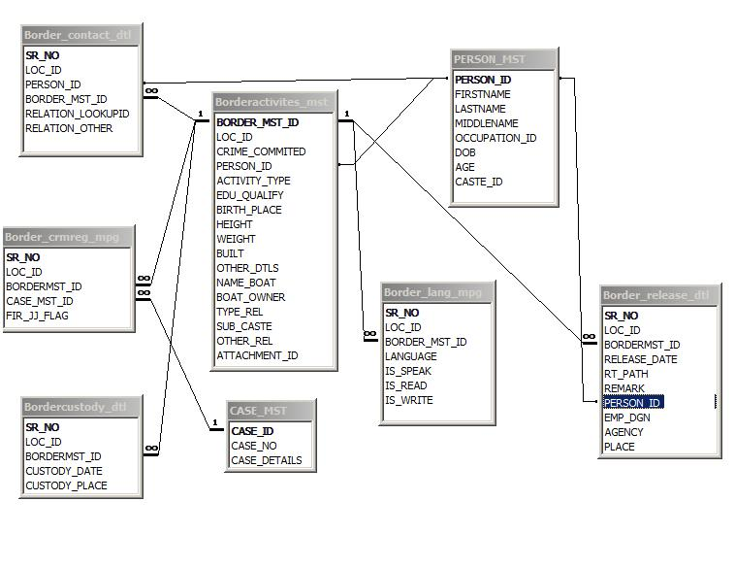

Fig 3.5.1.1 Table Relationship Diagram

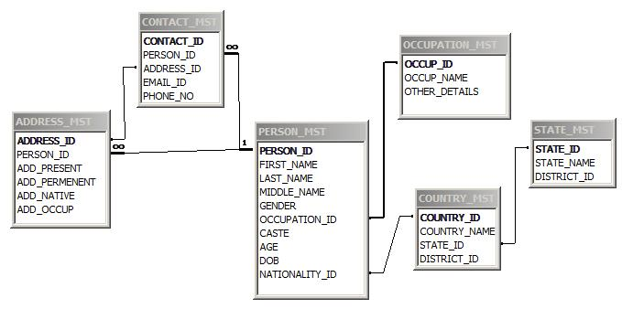

Fig 3.5.1.2 Table Relationship Diagram

